# Benchmark study for similar Special Economic Zones projects

Based on documentary research as well as the Consultant's experience in advising clients on different modes of PPP procurement for similar projects around the world, we have conducted an international benchmark study of similar PPP projects for economic service zones, namely:

* The Glo-Djigbé Industrial Zone (GDIZ), Benin
* Special Economic Zones in Bangladesh
* Free Industrial Zone Hualing Kutaisi 2, Georgia
* Lekki Free Trade Zone, Lagos State, Nigeria

## The Glo-Djigbé Industrial Zone (GDIZ), Benin

### Project presentation

GDIZ is an integrated industrial area, developed over an area of 1,640 ha with the aim of creating flourishing value chains ranging from raw material supply to the export of finished products, including resource processing.

GDIZ’s objective is to provide investors with a gateway to the African landscape by providing them with the necessary infrastructure, creating an atmosphere conducive to business and supporting them in promoting their products through their ecosystem approach.

GDIZ is strategically located on a motorway that is connected to the airport and the Autonomous Port of Cotonou (PAC). GDIZ will be close to the future planned rail line for better economical freight management. In addition, the GDIZ has a single window, a police station, and a fire station, among many other facilities.

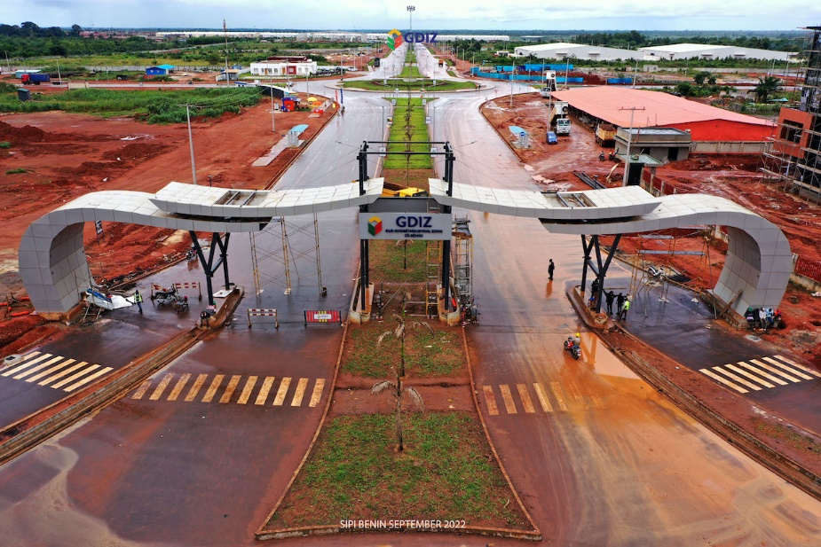

Figure 3: The Glo-Djigbé Industrial Zone (GDIZ), Benin

### Project Structure

The Glo-Djigbé Industrial Zone (GDIZ) is a groundbreaking project in Benin, established through a public-private partnership. This partnership between the Republic of Benin and Arise IIP follows a joint venture structure, with the government holding a 35% stake and the private sector contributing 65%. Under the agreement, Arise IIP has taken on the responsibility of designing, financing, and operating GDIZ. As a testament to their commitment, Arise IIP has invested a staggering 1.5 billion USD to cover the entire construction cost of the industrial zone. The project area spans a substantial 1640 hectares, with the first stage already completed, comprising 400 hectares. GDIZ encompasses various vital components, including textile companies, cotton transformation facilities, and training centers, among others.

## Special Economic Zones in Bangladesh

### Project presentation

The Special Economic Zones (SEZs) project in Bangladesh is an ambitious endeavour aimed at spurring economic growth and attracting foreign direct investment (FDI) to the country. These SEZs are designated areas that offer unique incentives, infrastructure, and facilities to both local and foreign businesses, promoting industrialization and export-oriented industries.

One of the primary objectives of the SEZ project is to diversify the economy and reduce dependency on traditional sectors. The SEZs cater to a wide range of industries, including manufacturing, textiles and garments, electronics, information technology, pharmaceuticals, and automobile manufacturing, among others. By focusing on these sectors, Bangladesh aims to enhance export competitiveness, create employment opportunities, and boost overall economic growth.

The SEZs offer numerous benefits to investors, such as tax incentives, duty-free import of machinery and raw materials, streamlined bureaucratic processes, and improved infrastructure. The government has taken significant steps to ensure ease of doing business within the SEZs, implementing a one-stop service center that provides comprehensive support to investors, including licensing, permits, and utilities.

To date, several SEZs have been established across Bangladesh, including the Bangabandhu Sheikh Mujib Shilpa Nagar 1 (BSMSN-1) and the Mongla Economic Zone, among others. These zones provide a conducive business environment, with well-planned industrial layouts, reliable power supply, water treatment facilities, and modern transportation networks. The different zones Cover an expansive area of 1,500 acres of land.

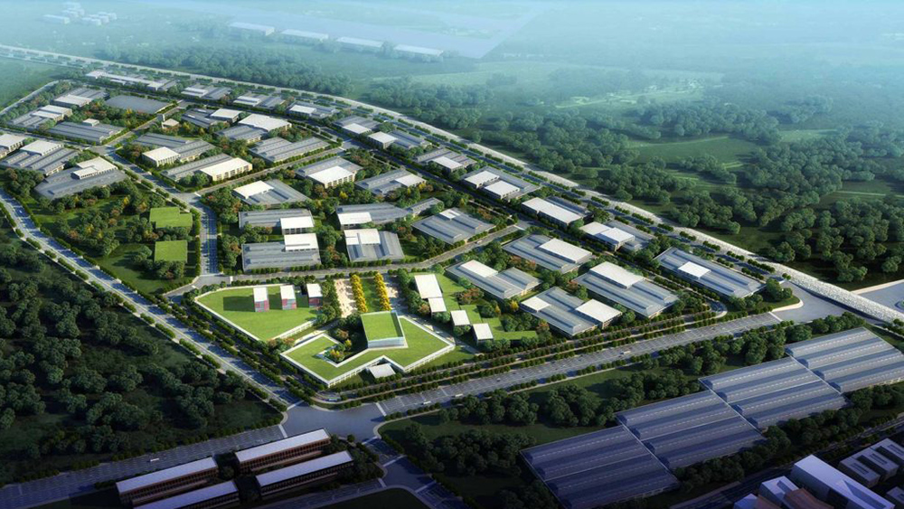

Figure 4: Special Economic Zone in Bangladesh

### Project Structure

The SEZ project is structured as a public-private partnership, with the Bangladesh government playing a crucial role in providing policy support, land allocation, and infrastructure development. Private investors, both domestic and international, are encouraged to invest in the SEZs, bringing in capital, technology, and expertise to accelerate industrial development.

The development of the Bangabandhu Sheikh Mujib Shilpa Nagar 1 (BSMSN-1) and the Mongla Economic Zone in Bangladesh for example follows a unique project structure based on a private lease agreement. This arrangement has facilitated the establishment of these industrial zones, attracting significant private investment.

The projects have witnessed an impressive direct total private investment of over $3.9 billion, reflecting the confidence of investors in the potential of these zones.

The projects have received support from the World Bank, with credits totalling $170 million. This contribution from the World Bank demonstrates their recognition of the project's potential to drive economic growth and create employment opportunities in the region.

Additionally, the project has forged a valuable partnership with the United Kingdom's Department for International Development (DFID) / Foreign, Commonwealth, and Development Office (FCDO). Through this collaboration, a recipient-executed grant of more than $20 million has been administered to finance crucial works and provide technical assistance. This partnership underscores the international support and cooperation involved in the successful implementation of the project.

## Free Industrial Zone Hualing Kutaisi 2, Georgia

### Project presentation

The Hualing FIZ project started in June 2012 when the Georgian government and the Hualing Group (China) signed a memorandum on establishing a free industrial zone in the city of Kutaisi. For a US$ 40 million investment, the Hualing Group was granted 36 hectares of land for use.

The Hualing Free Industrial Zone is located in the city of Kutaisi on the premises of a former motorcar factory close both to a highway and to a railroad. The distance to the closest airport in 19 kilometers (less than 12 miles) and to the seaport in Poti – 95 kilometers (less than 60 miles).

The following products were manufactured in the zone: ferroalloys, solar panels, matrasses, paper, construction materials, furniture, and textile. Besides, wood and stone are processed in this Zone. It is worth noting that not only foreign companies are present here: around 25% of the FIZ companies belong to Georgian citizens. Many companies located in the Zone use it as a logistic center that allows optimizing the import – warehouse – export commerce. A substantial portion of the Hualing FIZ businesses is engaged in processing wood and manufacturing consumer goods.

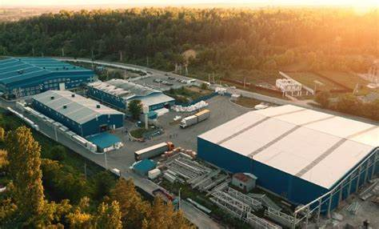

Figure 5: Free Industrial Zone Hualing Kutaisi 2, Georgia

### Project Structure

The agreement between the Georgian government and the Hualing Group on establishing a tax haven was signed on May 20, 2015. This agreement granted the Hualing Group the status of the FIZ administrator. According to the agreement, the precise area of the Zone is 359 251 square meters (around 429 660 square yards), and the contract duration is thirty years.

Over the two and a half years the Hualing FIZ has been in operation, it has managed to attract to Georgia US$ 70 million in investment money. As of June 2018, 130 business companies are registered in this Zone.

## Lekki Free Trade Zone, Lagos State, Nigeria

### Project Presentation

The Lekki Free Trade Zone (LFTZ) is located 60 km east of Lagos on a sandy peninsula with the Atlantic Ocean to the south and Lekki Lagoon to the north. The LFTZ is part of the overall multi-use development plan for a new city on the Lekki peninsula which includes residential, commercial, industrial, logistics and recreational development as well as a new airport and deep-water port. The illustration plan reflects a large-scale vision plan that has been completed for the entire Lekki peninsula.

The development objective of the LFTZ project is to establish a free economic zone and an international city with multi-functions of industry, commerce, trade, tourism, recreation, and residence to attract foreign investment, create employment and expedite economic growth.

According to the March 2009 Feasibility Study, Phase I of the LFTZ (the China-Nigeria Economic and Trade Cooperation Zone) consists of the development of 1,176 ha over a period of five years with a start-up area of 780 ha. Based on more recent information, it is understood that this plan has been scaled down considerably. The start-up phase, which is currently under construction, now of a total land area of 154 ha. The first stage of this development involves the construction works for the provision of necessary infrastructure facilities, including site clearance and levelling (partial), internal roads, landscaping, water supply and sewerage, power supply, telecommunications, gas supply, industrial workshops, warehousing/logistics/storage facilities, public/commercial facilities, residential buildings, and environment protection facilities. This is expected to take up to five years to complete and will encompass 109 ha. The second stage, also estimated at five years, will see the completion of construction of the remaining 45 ha of land. The total project cost is estimated at US$400-500 million, with the financing sources from the developer, Chinese government, Lagos government and private investors. The project envisages a mixed use of industrial companies, service-sector companies, commercial property, residential property, and other amenities, such as school, hospital, and hotels. The developer estimates that the full development of the zone could create more than 100,000 new jobs directly and many more indirectly once the zone was fully occupied and completely operational.

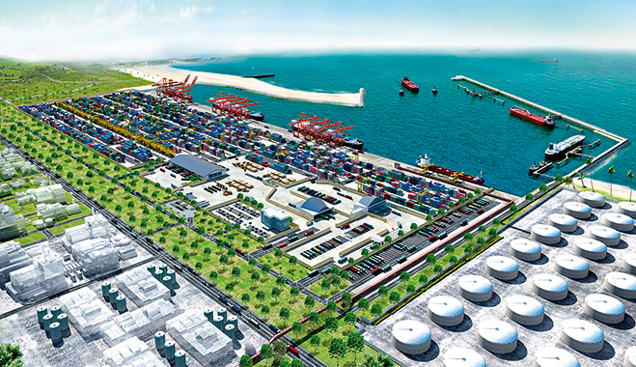

Figure 6: Lekki Free Trade Zone, Lagos State, Nigeria

### Project Structure

The zone is owned by a joint venture between a Chinese consortium - China-Africa Lekki Investment Co. Ltd (CALIC) (60 percent), the Lagos State Government (20 percent) and its subentity, Lekki Worldwide Investment Ltd (20 percent). The Chinese consortium CALIC is an investment holding company registered in China solely for the purpose of investing in the Lekki FTZ. CALIC consists of CRCC (35 percent), CADF (20 percent), Nanjing Jiangying Economic and Technology Development Corporation (NJETDC, 15 percent) Nanjing Beyond Investments Limited (NBIL, 15 percent) and China Civil Engineering Construction Corporation Ltd (CCECC, 15 percent). Lekki Worldwide Investments is an investment company, owned largely by the Lagos State Government: 40 percent of Lekki Worldwide Investments is owned by LSDPC, the Lagos State Government Development Corporation, with another 40 percent owned by Ibile Holdings, the investment company of Lagos State. The Lagos State government allocated 16,500 ha of land of which 3,000 ha has been officially transferred to the developer so far. The Lagos State Government’s equity share is in return for providing the land and the 50-year right to operate the zone to the Chinese consortium. The State Government is also contributing towards the construction costs of the zone infrastructure, together with the developer.

Completed works in the start-up phase include an entry gate and associated offices, land clearing, construction of around 14 km of internal roads and drains, water supply from six bore wells and power supply from a 1,750-kw diesel generator. Two access roads have been built (including a toll road) and a water road is also being planned. A 7 km drainage canal is under construction. A Lekki One Stop Shop has been established at the zone and was formally launched in September 2010.

## Summary of the benchmark study, lessons learned and main recommendations.

According to the benchmarks mentioned above and the lessons learned from them, there are four essential practices that need to be carefully followed when designing and developing a special economic zone (SEZs) project to increase the likelihood of success:

1. **Choose the right location:**

**The location choice of an SEZ could be the “make-it-or-break-it” factor**. International experience shows that SEZs tend to flourish in core areas and around gateway infrastructure (seaports and airports) (World Bank 2019). Cities offer features that tend to be essential to the success of large-scale, labour-intensive SEZs, including access to deep and specialized labour pools, specialized suppliers and business services, and social infrastructure, as well as connectivity to domestic, regional, and global markets. However, many country governments continue to try (and fail) to use zones as regional development tools. Some governments put social equality agenda above economic viability when deciding to locate at least one SEZ in each “lagging” or remote region, but few governments have done enough to address the infrastructure connectivity, labour skills, and supply access that the regions tend to lack.

**Connectivity among individuals, firms, countries, and regions is increasingly understood as a key factor in achieving competitiveness and sustainable, inclusive economic growth**. Connectivity has both physical and policy dimensions. To be a catalyst for structural transformation, zones need the following: to have or to be linked to key elements of transportation infrastructure (such as ports, railways, and highways) with good trade logistics and customs services; to be well matched to local resources that leverage the nation or city’s comparative advantages (such as agro-processing or electronics); to be part of the global value chain; and to be focused not only on exports, but also on the domestic market.

1. **Foster a conducive business environment with a reform-oriented mindset:**

**One of the key objectives of zone programs is to overcome the constraints (both soft and hard) for businesses to efficiently operate in an economy**. Instead of focusing largely on fiscal incentives, such as tax holidays and free land, zones should strive to provide an environment conducive to business and to foster firm-level competitiveness, innovation, local economic integration, and social and environmental sustainability. Such programs must provide good infrastructure, such as power, water, roads, and telecommunications. Meanwhile, the SEZ policy framework should be part of the broader national policy context, including investment, trade, and tax policies, and zones can be used to “pilot” policy, legal, and regulatory reforms to support economic development, as evidenced in many East Asian countries. What is important is to make sure that benefits (e.g., the simplification of customs procedures) can then be made available economywide.

**In almost all the successful zones in the world, basic infrastructure is of high quality, and public services and aftercare are efficient and effective**. One of the important value-added features of SEZs is the one-stop-shop (OSS) service. Since a zone program involves many government stakeholders in charge of such factors as land, transportation, utilities, customs, taxation, finance, immigration, and skills, an effective OSS could make the public services, such as registration, licensing, permits, taxation, and customs clearance, much simpler and efficient. For OSS to work, it is particularly important to establish a proper dialogue, coordination, and cooperation mechanism among the central, provincial, and local governments and across different government agencies. Wherever the capacity is permissible, such services could also be extended to firms outside zones by leveraging the increasingly available digital technologies.

1. **Increase the market contestability through a rigorous market demand assessment and private sector participation:**

**Since a zone program or project is an expensive undertaking, it requires careful planning, design, and management**. Besides the development costs, which involve the basic infrastructures, land acquisition and development, and green facilities, the project also includes the cost of common services in the zone, as well as the public revenues foregone from the various incentives often associated with a zone program. Many low-income countries must rely on international donors or development agencies to launch such programs. However, the results are not guaranteed. As mentioned, because of the high-risk nature of such programs, many of them end up being “white elephants.” That is why the implementation capacity of the government or private sector is crucial for success.

**Ensuring that the zone programs and projects are based on business demand is of paramount importanc**e in order to avoid creating the poorly performing white elephant zones. The planning process should include a rigorous assessment of the demand situation (preferably done by the private sector) that will not only analyse the global, regional, and domestic industrial and investment trends and the local comparative advantages, but also a solid understanding of the demand for industrial infrastructure in the designated area by the business sector, which often involves an investor or pre-investor survey to potential investors (both international and domestic). The demand assessment is typically part of a comprehensive feasibility study of a specific site and serves as the basis for the master planning and economic and financial analyses of the proposed zone. All this information will be used to determine the viability and market contestability of the zone.

**To ensure smooth and efficient operations of zones, private sector participation is encouraged** and should be provided for in the SEZ legislative framework or in the country’s broad land market legal framework, enabling the private sector to invest in various kinds of land, including industrial land. This will not only reduce the financial burden to the government, but also reduce the risks by bringing professional expertise into play, thus increasing the chance of success.

**Private sector participation can take the form of either a pure private sector approach or a public-private partnership (PPP) approach** and can be arranged at the distinct stages of the zone project from planning and development to management and operation. The level of demand, local context, risk appetite of private developers, and government strategy will determine the most suitable configuration of private sector participation, ranging from wholly private to a PPP approach where experienced private sector partners can be brought in to help with the planning, infrastructure development, and management of the SEZ.

1. **Maximize the positive spillovers through an inclusive and sustainable approach:**

**The success of modern zones is increasingly entwined with the local economy to achieve structural transformation of the host economies**. Zones need to build on local comparative advantages and try to have local suppliers as part of their value chains through an inclusive approach. Proactive identification of opportunities, matching efforts and training programs between firms within and outside zones, would greatly enhance zones’ impact. In many countries, such as those in Sub-Saharan Africa, zones are often criticized as being enclaves without much linkage to the local economy. Evidence from East Asia shows that, eventually, zones with strong linkages to the local economy tend to be the most successful. To fully benefit from the zone programs, governments and zone management need to consider the local comparative advantages as they target priority sectors. Governments and zone management should also help local firms link with zone investors through supply chains or subcontracting relationships. These backward and forward linkages hold the potential to maximize spill-over effects on the economic benefits (such as technology transfer, skills upgrading, and productivity gains of local firms) that accrue beyond the zone itself.

**In addition, it is important to make zones greener and sustainable to upscale their competitiveness stance in the global market**. Increasingly rigorous environmental and social standards of international investors mean that SEZs that adopt the principles of eco-industrial development and that align with or go beyond international good practice compliance requirements may have a competitive advantage over other locations competing for the same investors. In this regard, zones are encouraged to voluntarily adopt the EIP framework to make themselves resource-efficient, climate friendly, and overall greener. An EIP can broadly be defined as “a dedicated area for industrial use at a suitable site that ensures sustainability through the integration of social, economic, and environmental quality aspects into its siting, planning, management and operations.” It has increasingly been recognized as an effective tool for overcoming challenges related to inclusive and sustainable industrial development within the scope of the Sustainable Development Goals. However, it is also used to respond to global demands for a green supply chain and to reduce resource constraints through improved resource management and conservation while ensuring national and international climate change commitments are met. While zones can be the pilots, such good practices should be promoted throughout the economy.

Besides the dos, there are some negative lessons in planning, developing and operating SEZs that should be avoided, which are summarised next as four do not:

1. **Lack of strategic planning and demand-driven approach:**

**International experience shows that effective zones are an integral part of an overall national, regional, or municipal development strategy and build on strong demand from business sectors.** For public zones, governments need to clearly define the role and objectives of the zone initiatives in their overall economic development agenda and to conduct thorough planning that involves all the major stakeholders in the process. Such a process will help to build a consensus within the government and throughout the country or region, thus gaining broad support. To anchor the zone programs on a solid market-based foundation, the private sector must be involved from early on to understand its specific needs and constraints and to test the zone approach. If a zone initiative is justified, the preliminary locations, sectors, and potential investors need to be identified; some cost-benefits analysis needs to be conducted; and a well-thought-out implementation plan needs to be developed.

**However, in many cases, a strategic planning process is skipped or compromised.** Many decisions are made through a purely top-down approach, without considering the real needs of the private sector. Some zones are politically motivated even without a proper feasibility study, and some are established mainly for equality purpose, not necessarily in line with a country’s or region’s economic development strategy. Given the nature of SEZs, they may not be a suitable development instrument in a peripheral and remote region. A supply driven SEZ designed without business demand is a recipe for failure.

1. **Failure to address the critical market and government failures:**

**From the economics point of view, an SEZ instrument is justified because of its possibility to complement market forces and to help deal with certain market and government failures.** The important market failures and government failures that SEZs are intended to address would include a malfunctioning land market, deficient industrial infrastructure (such as power, water, gas, telecommunications, and waste treatment) needed for industrial agglomeration, and poor regulatory and business environment caused by coordination failures within governments or between the government and private sector. Strictly speaking, an SEZ approach is needed only when all the “failures” exist at the same time, otherwise an industrial park might be sufficient in cases where the regulatory and business environment is not the main constraint to investment, but rather deficiencies related to available and reliable sustainable infrastructure and investor services.

**However, in many zones, even the basic infrastructures, such as power and roads, are not properly provided**. A World Bank study of six African zone programs (Ghana, Kenya, Lesotho, Nigeria, Senegal, and Tanzania) shows that the downtime in zones (measured by hours) because of power shortages is still quite high in absolute terms in most African zones despite some reduction compared with outside zones—on average, the reduction is about 54 percent in African zones versus 92 percent in non-African zones. Also, in many countries, the OSS does not live up to its name because of poor intra- or intergovernmental coordination. In such cases, the SEZs are unable to serve their true purpose. And in some countries, governments decide to implement SEZs to address other policy issues, such as regional development, notwithstanding the location of the zone and access to markets.

1. **Poor policy and legal environment and weak implementation capacity:**

**In an SEZ program, a predictable, transparent, and streamlined (not multiple or even self-contradicting) legal and regulatory framework is essential to provide protection and certainty to the developers and investors and to ensure the clarity of roles and responsibilities of various parties involved**. Such a framework also helps to ensure that the zones attract the right investments and are implemented with proper standards. It will also help avoid or minimize unpredictable risks, such as political setbacks or interference and land speculation, among other factors. In addition, the implementation capacity of government or private developers and operators are also among the key determinants of zone success. Governments and private sector players with strong expertise in planning, designing, and developing zones or industrial infrastructure programs tend to deliver better results. Strong, long-term government commitment provides an additional guarantee for the success of zones by ensuring policy continuity and adequate provision of various public goods and services. Meanwhile, close coordination between the central and local governments and clarity over their roles are important for the smooth implementation of the different programs.

However, in many low-capacity countries, especially those in Sub-Saharan Africa, the current legal, regulatory, and institutional framework for SEZs is either outdated or does not exist, and in some cases, the zones have been launched or built without a proper framework in place. This tends to create a lot of confusion and to deter potential investors. Many governments or private developers and operators have never designed or run a zone program before, and they adopt a “learning-by-doing” approach, which makes such high-risk programs quite vulnerable. In such cases, if zones are indeed necessary, it might be better off to enable the private sector–led industrial zones with better regulations and better public services.

1. **Inability to mitigate the environmental and social risks**

**Because of the nature of SEZ projects, they often need to involve land acquisition and resettlement of displaced people, which makes them highly susceptible to environmental and social risks.** Therefore, it is indispensable in SEZ programs and projects to properly identify and assess such risks during the feasibility study and to develop sound mitigation measures. Failing to do so may make or break such projects, which has been the case in some African and South Asian countries, for example.

The choice of zone location should try to involve as less displaced people and businesses as possible to minimize the social risks. Also, a thorough consultation process should be conducted with all the relevant stakeholders, especially the local communities that would be affected by the project. The displaced people should be properly compensated and resettled. As a good practice, the affected people who may lose their means of living due to the project should be trained or reskilled and employed within the zone, if they are still at a working age. The government and the zone developer or operator can jointly do this. Zones should also adopt a high standard regarding worker compensation and protection. To satisfy the needs of underrepresented worker groups (such as female workers), the zone should create an ecosystem to provide services and infrastructure, such as day care centres and kindergartens.

In addition, some zones may host highly polluting sectors, such as textiles, leather, and petrochemicals, and may create severe damage to the natural and living environment. Such situations can cause huge setbacks or even social unrest. To avoid or minimize such risks, zones should be eco-friendly and environmentally sustainable. An effective way to do so is to adopt the international EIP framework mentioned earlier.

To integrate and operationalize the EIP framework, zones should set up their own EIP performance indicators based on the guidance provided in the EIP Practitioner’s Handbook. They also should develop a rigorous system to regularly monitor and evaluate their performances in zone management and in economic, social, and environmental aspects and should report to key stakeholders. The absence of such monitoring, evaluation, and reporting system may result in zones diverging from their initial purposes.